- SHOWTURTLE
- MOVE 50
- DRAW 50
- POINT 0
- RIGHT 45
- LEFT 45
- COLOR RED
- THICK 5
9)-----------------------------
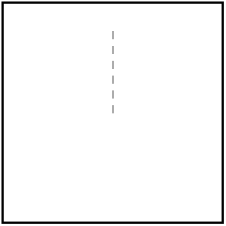
REPEAT 6
DRAW 10
MOVE 10
NEXT
END

10)-----------------------------
GO DASHEDLINE
END

# DASHEDLINE
REPEAT 6
DRAW 10
MOVE 10
NEXT
RETURN

11)-----------------------------
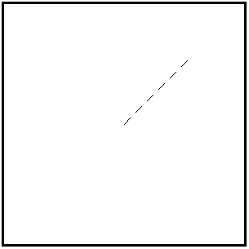
RIGHT 45
GO DASHEDLINE
END

# DASHEDLINE
REPEAT 6
DRAW 10
MOVE 10
NEXT
RETURN

12)-----------------------------
SHOWTURTLE
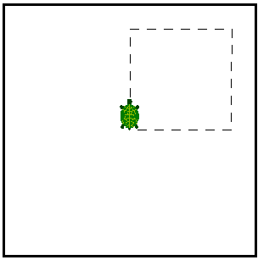
REPEAT 4
GO DASHEDLINE
RIGHT 90
NEXT
END

# DASHEDLINE
REPEAT 6
DRAW 10
MOVE 10
NEXT
RETURN

